Healthcare Data Analysis and Insights

By

V.HEMAPRIYA

**Contents:**

|  |
| --- |
| **Name of the contents: Page No:**  1.Project Description 3  2.Data Cleaning 4  3.Data Transformation 6  4.Data Exploration 10  5.Data Analysis 12  6. Final Thoughts 16 |

**1.Project Description:**

The healthcare industry generates vast amounts of data daily, providing valuable insights for healthcare providers and policymakers to improve patient care, allocate resources effectively, and manage healthcare costs. This project aims to analyse a comprehensive healthcare dataset comprising medical examinations, hospitalization details, and customer profiles to extract insights into patient health profiles, medical histories, and healthcare costs. By exploring relationships between various health metrics, identifying trends, and visualizing key patterns, we aim to deliver actionable insights to healthcare stakeholders for informed decision-making through rigorous data cleaning, transformation, exploration, and analysis.

**2.Data cleaning:**

1) Check for the number of missing values marked with '?' in each column of the “Medical Examinations” Table and "Hospitalization Details" Table.

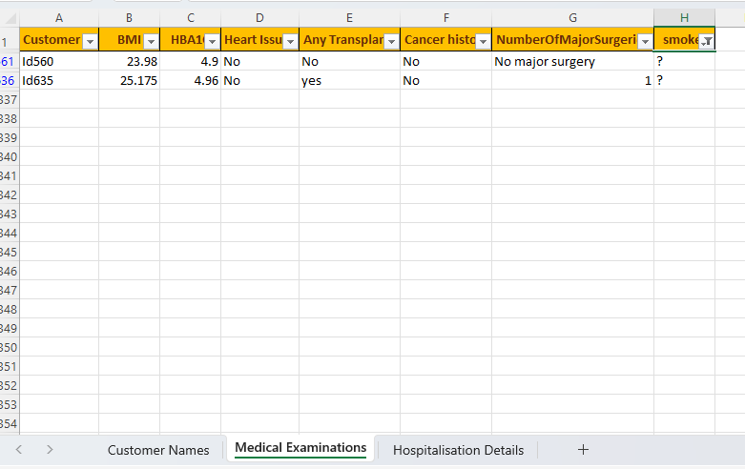

**Reformed Format:**

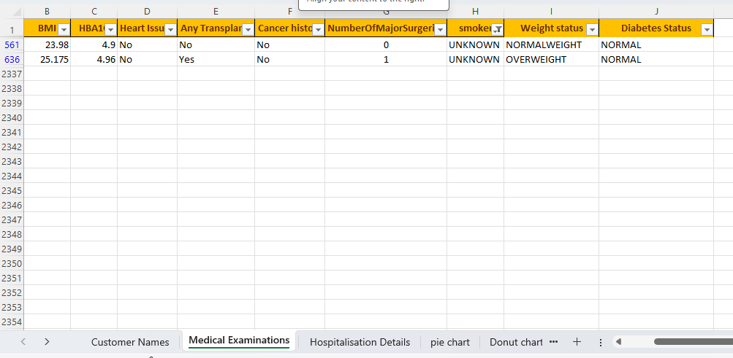

2) Fill in the missing values of ‘month’ with Sep and ‘year’ with its average rounded to the nearest integer. Determine the most frequently occurring values in the ‘smoker’, 'Hospital tier' and 'City tier' columns, and fill in the missing values accordingly. If any 'State ID' values are missing, consider filling them with 'Unknown' or using another appropriate strategy.

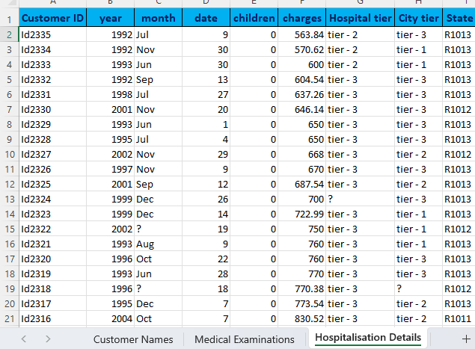

**Reformed Format:**

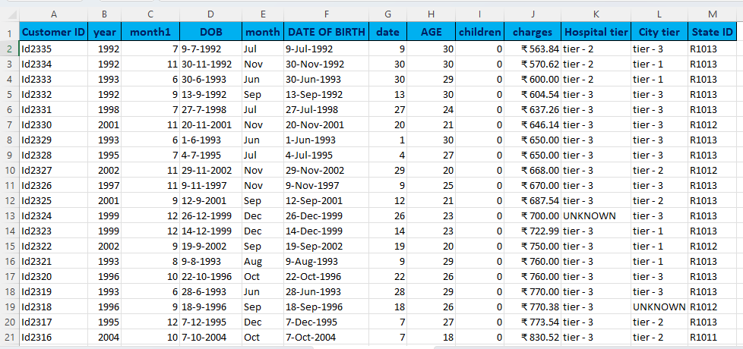

**2. Data Transformation:**

1) Split the ‘names’ column in the “Customer Names” Table into 3 meaningful columns: ‘Title’, ‘First Name’, and ‘Last Name’

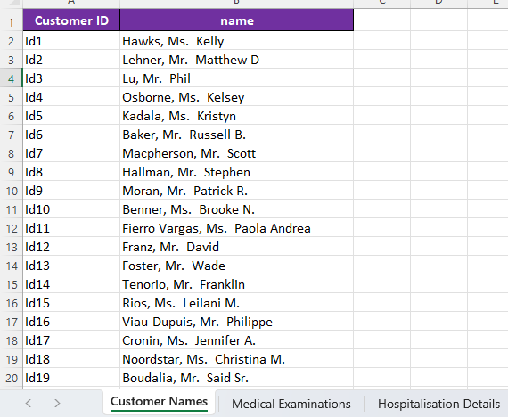

**Reformed Format:**

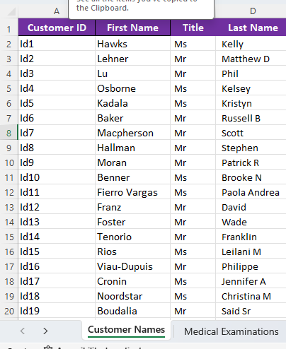

2) Convert the "Number of Major Surgeries" column in the “Medical Examinations” Table to numerical data by replacing non-numeric characters with meaningful numerical values.

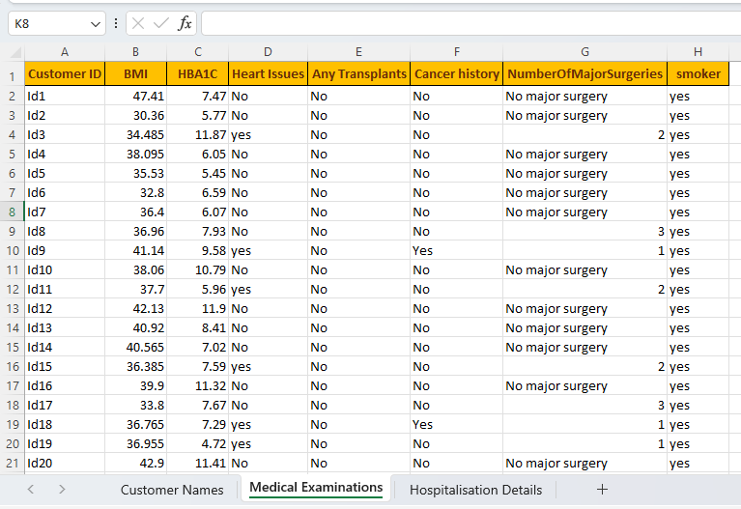

**Reformed Format**:

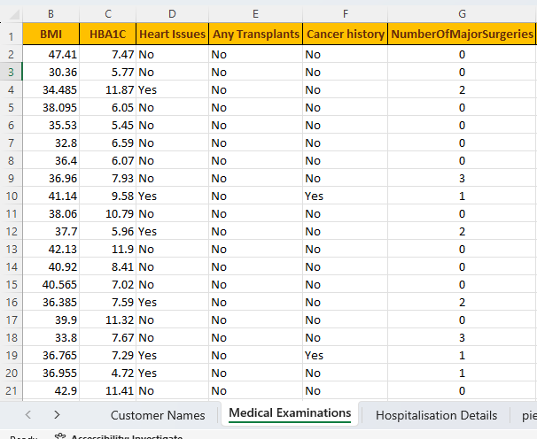

3)Create a new column named “Weight Status” that categorizes BMI into different categories as below. Create a new column named “Diabetes Status” and fill it as per the information given below:

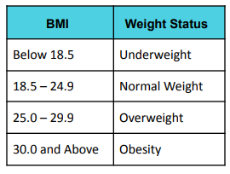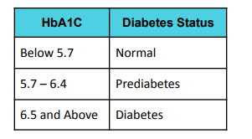

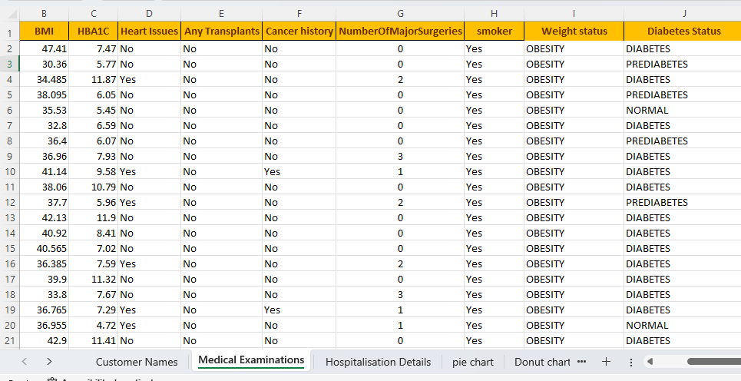

4)Merge ‘year’, ‘month’ and ‘date’ columns in the “Hospitalization Details” Table into one column named ‘Date of Birth’ and format it in ‘DD-MMM-YYYY’ custom format. Calculate the ‘Age’ of each customer based on their ‘Date of Birth’ and the date of collection of the dataset, which is 8 th June 2023. (Hint: Use the DATEDIF function. Format ‘charges’ column as currency ($)

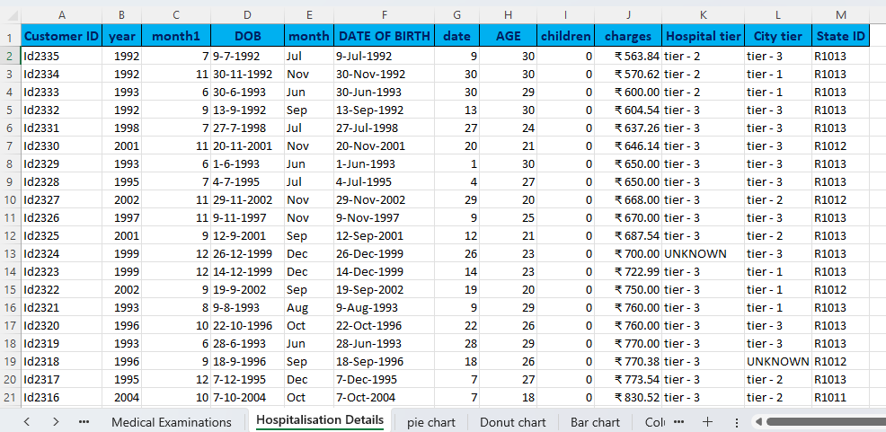

**3.Data Exploration:**

* Customer Names Table

➢ Are there any duplicate Customer IDs in the dataset? If yes, how many?

No duplicates were found in the analysis.

➢ How many customers are included in the dataset?

There are 2335 customers included in the dataset.

* Medical Examination Table:

➢ How many customers have a history of cancer?

➢ How many obese customers have heart issues?

➢ What is the total number of major surgeries performed on customers?

➢ Calculate the percentage of customers who have undergone any transplants.

➢ Find the average HBA1C value of customers who are smokers.

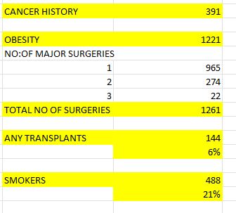

* Hospitalization details Table:

➢ Calculate all the Summary statistics for the ‘charges’ column.

➢ Find the average hospitalization charges for customers who are more than 50 years old

. ➢ Compare the total charges across different hospital tiers.

➢ Calculate the average charges for people who have more than 2 children.

➢ Find the integer average number of children of customers who are less than 40 years old

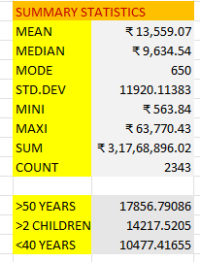

**4.Data Analysis:**

➢ Create a new sheet named “Healthcare", combine all three tables into one, using Customer ID as the common column, utilizing VLOOKUP.

➢ Retain the following necessary columns: Customer ID, First Name, BMI, HBA1C, Heart Issues, Any Transplants, Cancer history, Number of Major Surgeries, smoker, Weight Status, Diabetes Status, Date of Birth, charges, Hospital tier, City tier, State ID, Age.

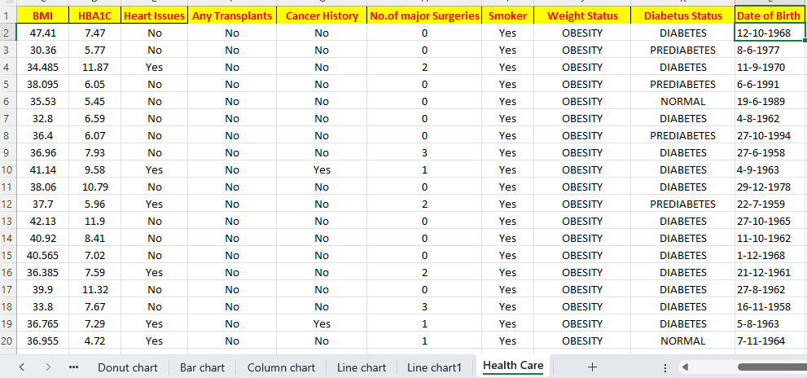

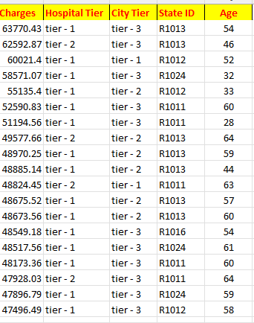

**Analysis using Pie/Donut Chart:**

➢ What is the distribution of cancer history among smokers and non-smokers?

➢ How does the total number of major surgeries and average HbA1C differ between patients with and without a history of transplants?

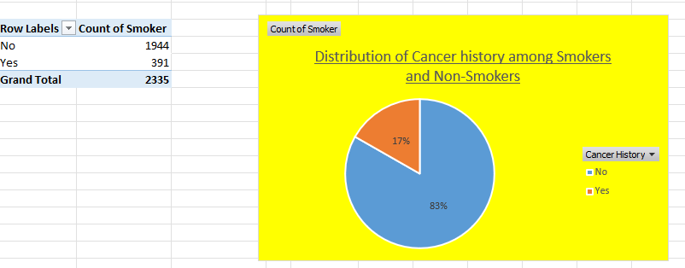

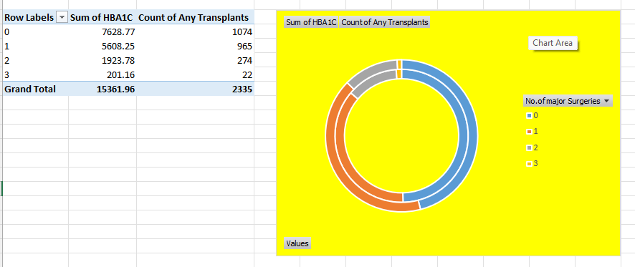

**Analysis using Column/Bar Chart:**

➢ How do healthcare charges vary based on different weight statuses and diabetes statuses?

➢ Can you compare the average charges for each hospital tier within different states?

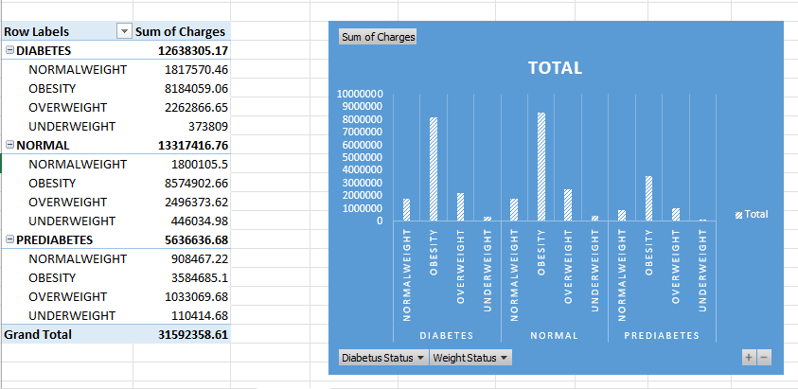

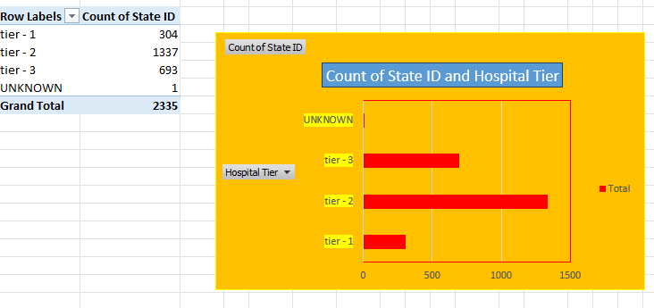

**Analysis using Line/Scatter Plot:**

➢ Is there any correlation between age and both BMI and HbA1C in the dataset?

➢ Explore the relationship between age and healthcare charges

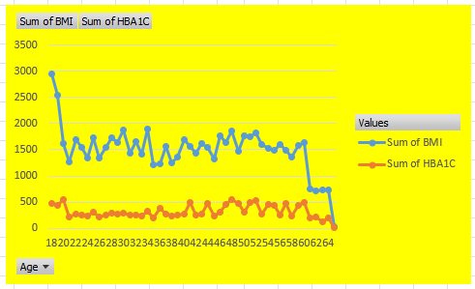

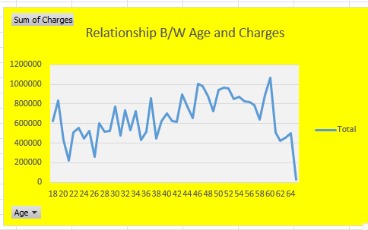

**6.Final Thoughts:**

* In summary, a comprehensive conclusion for a data analysis in a research study involves a strategic synthesis of key findings, their implications, and their contribution to the broader field of study.
* Healthcare data analytics helps managers in making predictions regarding resource availability, treatment facilities, checkups, etc. This has promoted strategic decision-making and also boosted the trust and faith of patients in medical treatments.
* We hope it helps you in your decision-making as healthcare data analytics professional.